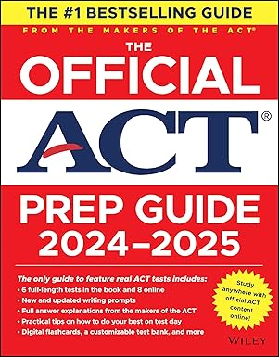 **₦**75,000

**The Official ACT Prep Guide 2024-2025: Book + 9 Practice Tests + 400 Digital Flashcards + Online Course**

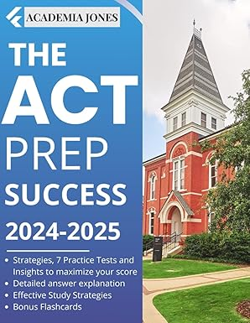 **₦**57,000

# The ACT PREP SUCCESS 2024-2025: Strategies, 7 Practice Tests and Insights to maximize your score: Effective Study strategies + detailed explanations + Bonus Flashcards

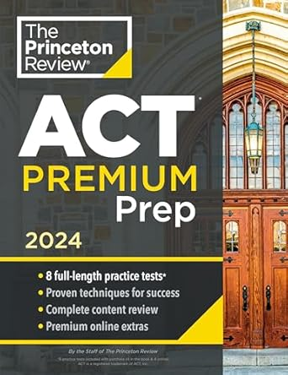 **₦**57,000

# Princeton Review ACT Premium Prep, 2024: 8 Practice Tests + Content Review + Strategies (2024) (College Test Preparation)

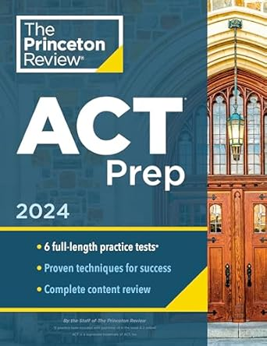 **₦**49,000

# Princeton Review ACT Prep, 2024: 6 Practice Tests + Content Review + Strategies (2024) (College Test Preparation)